**Summary 2 - A Deep Learning Approach for Predicting Process Behaviour at Runtime**

The main focus of this article is the use of AI to predict the next event, the next sequence of words in a running process, its behavior thanks to deep learning, the Recurrent Neural Network (RNN) and the Long Short Term Memory (LSTM).

* The first emphasis of this article is the importance of managing time through the managing process for various business applications, such as providing information to customer service agents about the time remaining until a case is resolved, or enabling case managers to identify risky cases and intervene early.
* The authors propose the use of Deep Learning to predict these events thanks to the neural network that consists of a layer of input cells, multiple layers of ”hidden” cells, and a layer of output cells.
* To do so, the use of the Recurrent Neural Network or RNN is recommended where each cell also feeds back information into itself, allowing it to maintain ”state” over time thus savekeeping previous knowledge and accumulates them to bring further and more precise predictions.
* The architecture of LSTM or Long Short Term Memory is favored for RNN which incorporate gate mechanisms that allow the model to decide what information should be forgotten or retained at each time step. Below is a typical RNN architecture with LSTM cells in a language prediction process (Horiztonal States are « Hidden cells ») :

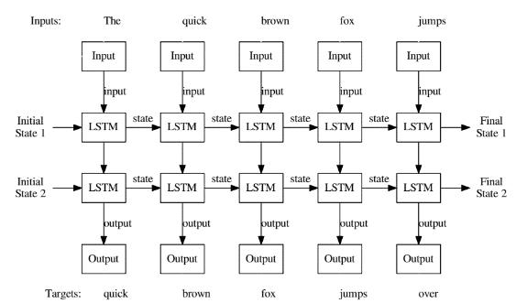

* Their work is mainly based on NLP or Natural Language Processing, allowing RNN to understand, interpret and generate human language in a natural way. although the RNN may encounter difficulties with the length of the sequences while the NLP can easily handle long sequences of several words.
* Results : Thanks to Tensorflow and data from the Business Process Intelligence Challenge (BPIC), the RNN shows results of great precision and increased performance
* In conclusion, the results of this new approach to prediction through deep learning with RNN and LSTM are very promising for the business process and emphasizes the prediction of the upcoming event and not of the event at time T. Nevertheless, the authors underline the limitations linked to the size of the traces processable by the RNN and the size of the architecture which must always be "enlarged" in particular in Hidden Cells, in LSTM and in the information provided .